The ‘Lutana’ Story
Loss of the Aircraft “Lutana” VH-ANK
on Square Peak, (Mt. Crawney) near Nundle in 1948

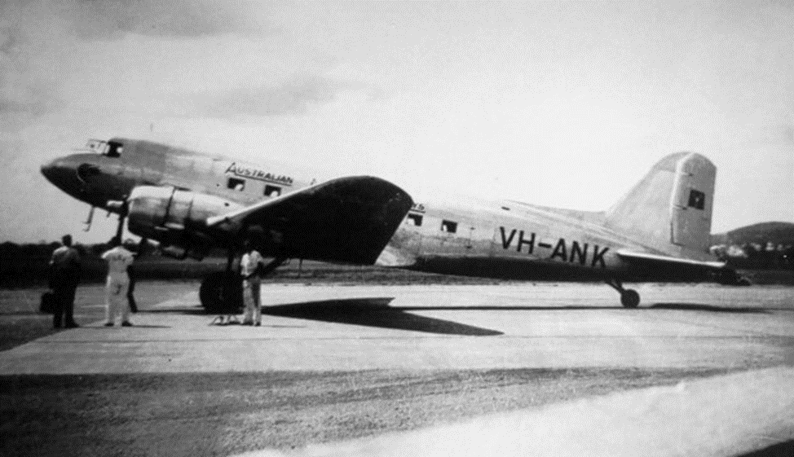
“Photographs are extremely rare and I am deeply indebted to John Wilson for this Gus Grulke shot taken at Archerfield, Brisbane, circa 1947”
http://www.edcoatescollection.com/ac1/austa2/ANA%20Fleet/VH-ANK.html

Prepared by Colin Cummins
from sources available on the Internet.
Nundle
2018

Loss of the Aircraft “Lutana” VH-ANK
on Square Peak, (Mt. Crawney) near Nundle in 1948

The most dramatic event in the history of Nundle was the crash of the Australian National Airways DC­3 airliner “Lutana” in 1948. The aircraft, VH‐ANK was on a flight from Brisbane to Sydney when it crashed into the top of Mt Crawney, about 7 kms south‐west of Nundle, on the night of Thursday, September 3, 1948. Thirteen people lost their lives in this accident. As a result of the subsequent enquiry, major changes were made to air traffic control procedures in Australia, and radio navigation equipment was considerably upgraded.
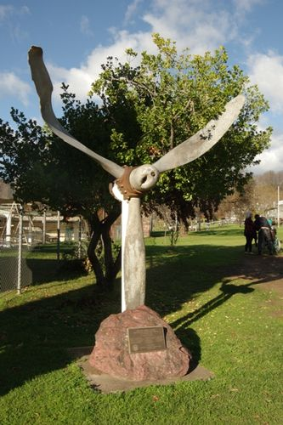
The “Lutana” Memorial in Jenkins St, Nundle.
From http://monumentaustralia.org.au/themes/disaster/aviation/display/22648-lutana-memorial

The “Lutana” took off from Brisbane’s Archerfield Aerodrome at 5.35pm and flew south into bad weather. The pilot, Captain J. A. Drummond, would normally have used a radio range at Kempsey to guide him. However, some other pilots alleged at the enquiry that this may not have been working on the night of the accident.
Pilots in those days also sometimes used radio broadcasting stations for position guidance. It is thought by some people Captain Drummond may have homed in on 2AD Armidale thinking it was 2HD Newcastle. The two stations had close frequencies, and with the weather so bad, there would have been a great deal of static, making it difficult for the pilots to be certain of the station.
Whatever the reason, the aircraft flew steadily inland into the mountainous area east of Tamworth. Then, at 7.56pm, the aircraft radioed that it was over Williamtown Air Force Base, and requested permission to descend from 6,000 feet (1830 metres) to 4,500 feet (1370 metres). Pilots knew they were over the top of radio ranges because they flew into a radio ‘dead spot’. Some freak of radio must have caused Captain Drummond to believe he was over Williamtown at the time. In fact, he was 87 miles (140 kms) from that base and well inland when the aircraft crashed.
It was normal practice for pilots of that era to turn out to sea from Newcastle and descend towards Sydney where there was no land. Obviously, Captain Drummond thought that was what he was doing. Instead, he must have been south‐west of Tamworth when he turned and began descending in the darkness through snow, hail and rain until his aircraft struck the mountain peak.
At the time, the mountain was known by a number of names: Mt Square Top; Mount Sugarloaf; Mt Ben Evers; Ben Nevis; and Black Jack. Today, it is shown on maps as Mt Crawney, and it is 4,500 feet (1370 metres) high. The height to which Captain Drummond was descending. It is one of the highest peaks anywhere between Sydney and the Queensland border.
The aircraft made its last short radio transmission at 8.12pm. From stopped watches found in the wreckage, it seems the aircraft crashed at 8.15pm, only three minutes later.
When it was obvious the aircraft was overdue, a major search was conducted. Because the pilot’s radio message saying he was turning out to sea from Williamtown, the search was concentrated in that area. An oil slick was found off the coast, and many people reported hearing an aircraft in the Wyong and Gosford area about 8.15pm.
But a senior pilot of East‐West Airlines, Captain Ron Walesby, had a hunch that if the aircraft had flown inland to avoid bad weather, it could have struck one of the high mountains in the Great Dividing Range. He suggested to his colleagues they keep a watch over the mountains of the Liverpool Range, which includes Mt Crawney, on their daily flights between Sydney and Tamworth.
On Saturday, September 5, one of Captain Walesby’s colleagues, Captain J. C. Paterson, spotted the wreckage shortly before 1pm while flying from Tamworth to Sydney in an East-West Airlines aircraft.
Searchers from Nundle, Wallabadah, Quirindi and Tamworth set off to find the wreckage. The going was so rough they had to complete the climb on foot. It was very cold, and there was snow on the ground round the wreckage. First on the scene was a Wallabadah grazier, Mr. Fred Golland, who was one of a party of three. He found a scene of devastation, with the wreckage strung over 300 metres. There had been a great fire after the crash, and all but two of the bodies were burnt beyond recognition. The aircraft had been flying slightly south of east when it hit; consistent with the theory Captain Drummond thought he was heading out to sea. Some 25 searchers spent a freezing night beside the wreckage before carrying the bodies down to Nundle. The remains were transported to Tamworth where an inquest was held. Several days later, they were buried in Tamworth Cemetery.
At first, the Federal Chifley Government resisted the holding of an inquiry, but public and Opposition pressure was such that the Minister for Air, Mr. Drakeford eventually announced the appointment of Mr. Justice Simpson to look into all aspects of the disaster.
His enquiry was long and searching, but he was unable to say definitely why the pilot was so far off course, and why his radio equipment did not indicate to him hi true position. Captain Drummond was a very experienced pilot, with wartime flying experience, and was regarded by his colleagues as very competent.
In his report, Mr. Justice Simpson exonerated the pilot from blame. But he was scathing in his criticism of Department of Civil Aviation methods, especially air traffic control system, and the standard of equipment provided.
His report was strongly attacked in Parliament by Mr. Drakeford, the Minister who had appointed him to make it. But Mr. H. F. Walsh, manager of Australian National Airways, said Mr. Drakeford’s criticism was outrageous. Opposition members, including Mr. Falkiner (Lib. Tasmania), a highly decorated wartime Pathfinder pilot, also condemned Mr. Drakeford for his criticism, and said Mr. Justice Simpson’s report was as fair and impartial as was possible in the circumstances. Mr. Falkiner was of the view that inadequacy of navigation aids was the only contributing factor to the crash. In the event, the DCA air traffic control system was considerably overhauled, and better air navigation equipment was installed, so it cannot be said the 13 “Lutana” crash victims died in vain.
There was not a great deal of the aircraft left after the crash and fire. The tail was the only substantial part that was relatively intact. What did remain was eventually bulldozed and buried. Some small pieces, however, were eventually recovered, and are preserved in the Nundle Museum.
In the past few years, one of the aircraft’s propellers was recovered by the people of Nundle, and set up as a memorial to the victims. Many relatives of those who lost their lives in the crash came to Nundle to take part in the dedication ceremony. They expressed gratitude to the people who had helped bring out the bodies, and to the people of Nundle for keeping alive their memory.
The Victims
Some 13 people lost their lives in the crash of the Lutana. Among them was Mrs Margaret Edgeworth McIntyre MLC of Launceston, who was the first woman Member of Tasmania’s Legislative Council. Another passenger was leading North Queensland jockey, Mr. Frederick John Coughlan, of Townsville. He was flying to Melbourne to race there. His stirrup irons were found in the wreckage.
Pilot of the aircraft was Captain J. A. Drummond, of New Farm, Brisbane. His co-pilot was First Officer J. R. A. Atkinson, of Chernside, Brisbane. The hostess on the flight was Miss Brenda Margaret Wise, of Elmhurst, Victoria. Miss Wise had trained as a nurse at Ararat and Maryborough Hospitals in Victoria before joining ANA. She was an accomplished horsewoman.
Other passengers were: Mr. Edmund Vincent Nelson, of East Brisbane, Mr. Eugene Thomas Nelson, of Brighton Beach, Victoria, Mr. William Joseph Falkiner, of Parkes, New South Wales, Miss Joyce Sotham, of Mackay, Queensland, Mr. Arthur Van Andel, of Hawthorn, Victoria, Mr. Charles John Rossiter, of Mascot, Sydney, Mrs L. C. Thompson, proprietress of the Country Club Hotel, Mackay, Queensland.
(This text is courtesy of the Nundle Museum and is a part of the “Lutana”display) Taken from http://www.norvilleaustralia.com.au/art_lutana_tragedy.html
Note:- Harold John Moorfoot who also died in this accident is not mentioned in the text above. CC

I would not have lived to be 88, Anne Shaw’s Story
Nundle had a special visitor recently, Anne Shaw and family. This is her story -
If hostess Miss Wise had not wanted to be back in Sydney that day, I would not have lived to be 88. I had been an air hostess with ANA (Australian National Airways) since March 1946. On 2 September 1948, I was rostered for ground duty at Archerfield, which was a grass paddock with no defined runways. The day had been uneventful and I was packing up to go home when the captain of the 5pm Flight 331 Lutana, a DC3 bound for Sydney, told me the scheduled hostess had not turned up for the flight. "Anne, it looks as though you will have to come with us," he said. "Could you put the passengers on board please?" It was apparent by now the hostess was not going to show, so I was designated to hostess the flight.
Captain John Drummond and co-pilot John Atkinson carried out the preflight checks, and we were now ready for takeoff. As the aircraft started to roll into the wind, the throttle was closed just before liftoff. The captain had sighted the scheduled hostess running her hardest towards the aircraft. The tail of the DC3 was not far off the ground, so the exchange was fairly easy. Within minutes, Lutana VH-ANK was airborne, flying into the northeast wind heading for Sydney, and so I went home. But the aircraft did not reach its destination. It had crashed into Mt Crawney.
After my five years as an air hostess I married a country GP and have lived in Kingaroy since 1953. In 1976 I learnt to fly at the age of 55. My husband had been in the air force and regained his licence in the 1960s. My son is a jumbo captain and one of my daughters was an air hostess with Qantas. I assure you this is a true story. Anne Shaw.
From the Nundle Community Newsletter, March 2012 Issue, contributed by Nundle and District Lions Club, custodians of the Nundle Court House Museum.

Lutana VH-ANK. Douglas C-47A-45-DL. c/n 9999.
1943
Construction completed at Long Beach, California - August 1943. Built as a Douglas C-47A-45-DL. Delivered to the U.S.A.A.F. - August 6, 1943. Allocated U.S. serial number 42-24137. Transferred to Royal Australian Air Force under the lend / lease agreement - August 23, 1943. Allocated the R.A.A.F. serial number A65-17 with the radio call sign 'VHCTQ'. Delivered to R.A.A.F. Number 35 Squadron - September 8, 1943. Allocated to Number 33 Squadron - September 22, 1943.
1944
Wing centre section was badly damaged in landing accident - February 19, 1944. Delivered to RAAF Number 26 RSU for repairs.
1945
Test flown by Number 1 Aircraft Depot following extensive repairs - June 26, 1945. Allocated to Central Flying School - June 27, 1945. Transferred to 3 Aircraft Depot - May 31, 1945. Allocated to Number 37 Squadron to uplift engine for stranded Mitchell bomber - August 21, 1945. Transferred to Number 34 Squadron - September 5, 1945.
1946
Allocated to Number 3 Aircraft Depot and operated under charter by Australian National Airways - April 18, 1946. Operated under charter by Guinea Airways Ltd - September 1946. Withdrawn from RAAF service as it was surplus to requirements.
1947
Sold by Commonwealth Disposals Commission to A.N.A. - February 18, 1947. Delivered to Australian National Airways Pty Ltd - February 22, 1947. Converted to civilian standards by Australian National Airways with seating for 21 passengers. Powered by Pratt & Whitney R1830- S1C3G engines. Entered onto the Australian Aircraft Register (C of R?) as VH-ANK - March 7, 1947. Registered to Australian National Airways Pty Ltd. Aircraft was named 'Lutana' (the moon). Believed to have been operated by Butler Air Transport for short periods but exact details unknown
1948
Aircraft destroyed when it crashed near Square Peak, some 1.6 km north-east of Mount Crawney - September 2, 1948. Was operating regular A.N.A. Brisbane - Sydney service as Flight 331. This flight was being flown in poor weather conditions with an unserviceable autopilot and unreliable radio equipment. The radio range receiver had been flagged as faulty by previous crew when aircraft had arrived in Brisbane. Technicians in Brisbane had not been able to locate fault but changed the radio receiver anyway.
Due to the inaccurate position reports it was believed that aircraft had crashed into the sea near Williamtown.
Wreckage discovered next day by an East West Airlines pilot Captain J. C. Paterson. Working on a hunch he deviated from his scheduled flight from Tamworth to Sydney. Within minutes he located the aircraft's wreckage some 87 nm north-west from its last position report. All occupants of the aircraft had been killed in the crash.
Pilots had transmitted inaccurate position reports during the flight but the Flight Checking Officer at Sydney Airport who was responsible for monitoring the flight, had not detected these errors. When aircraft failed to arrive at Sydney Airport the Flight Checking Officer instituted emergency procedures at 21:05. Due to the inaccurate position reports it was believed that aircraft had crashed into the sea near Williamtown.
Wreckage discovered next day by an East West Airlines pilot Captain J. C. Paterson. Working on a hunch he deviated from his scheduled flight from Tamworth to Sydney. Within minutes he located the aircraft's wreckage some 87 nm north-west from its last position report. All occupants of the aircraft had been killed in the crash.
Flight crew: Captain J. A. Drummond; F/O R. H. Atkinson; Hostess B. M. Wise and 10 passengers. Subsequent investigation found that whilst trying to avoid the bad weather on its intended track from Brisbane to Sydney the crew had been misled by at least two defective instruments and had unintentionally headed in the wrong direction. Once becoming aware of their error a new heading was flown which unfortunately took them into the vicinity of Mount Crawney.
Initial impact was taken by the starboard propeller, nose and both wing tips, ripping them off. The aircraft continued over the summit of Square Peak and down the ridge's eastern face for some 400 metres. The following impact sheared off the port wing and overturning the fuselage before it struck the trees. The resulting fire destroyed the aircraft except for the rear fuselage section and the tail. Cancelled from the Australian Aircraft Register - November 18, 1948.
A comprehensive report on this crash can be found in MacArthur Job's book “Air Crash” Volume 2
From http://www.aussieairliners.org/dc-3/vh-ank/vhank2.html
Note:- Copies of MacArthur Job’s books “Air Crash Vol. 1 and 2” have been donated to the Nundle Court House Museum. CC
- - - - - - - - - -
The Nundle Court House Museum is open
Saturday mornings from 10.00 until 11.30
and Sunday afternoons from 12.30 until 4.00

